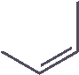

*Proceeding Paper*

# Novel IoT-Based Plant Monitoring System †

## Muhammad Haashir Absar 1, Ghulam Fiza Mirza 2,[*,](https://orcid.org/0000-0001-6124-7611) Warisha Zakai 1, Youail John 1 and Noman Mansoor 1

**Citation:** Absar, M.H.; Mirza, G.F.; Zakai, W.; John, Y.; Mansoor, N. Novel IoT-Based Plant Monitoring System. *Eng. Proc.* **2023**, *32*, 12. [https://doi.org/10.3390/ engproc2023032012](https://doi.org/10.3390/engproc2023032012)

Academic Editors: Muhammad

Faizan Shirazi, Saba Javed,

Sundus Ali and Muhammad Imran Aslam

Published: 24 April 2023



**Copyright:** © 2023 by the authors. Licensee MDPI, Basel, Switzerland. This article is an open access article distributed under the terms and conditions of the Creative Commons Attribution (CC BY) license [(https:// creativecommons.org/licenses/by/](https://creativecommons.org/licenses/by/4.0/)

4.0/).

1. Department of Electronic Engineering, NED University of Engineering and Technology, Karachi 75270, Pakistan; absarmhn101103@gmail.com (M.H.A.); warisha.zakai@gmail.com (W.Z.); youailjohn1@gmail.com (Y.J.); mansoornoman342@gmail.com (N.M.)
2. Department of Telecommunications Engineering, NED University of Engineering and Technology, Karachi 75270, Pakistan

**\*** Correspondence: ghulamfiza@neduet.edu.pk

† Presented at the 2nd International Conference on Emerging Trends in Electronic and Telecommunication Engineering, Karachi, Pakistan, 15–16 March 2023.

**Abstract:** The Internet of Things (IoT) plays a vital role in improving cultivation methods for greenhouses and providing farmers/landowners with the relevant information to make decisions for optimal yields. This paper presents an intelligent system, based on the IoT concept that remotely provides users with information related to the temperature, humidity, and soil moisture intensity for the monitoring of plant conditions. The Android application is designed for the users to monitor plant health parameters and manage the timing and frequency of water sprinkling. The sensors collect the readings and transfer them to the Blynk app using the ESP8266 Wi-Fi module. Based on the critical condition of the plant, the user can control the solenoid valve via an Android application to maintain the healthy state of the plant.

**Keywords:** Internet of Things; Android application; plant health monitoring

## 1. Introduction

Conventional greenhouses require huge infrastructures; among their obstructions are a lack of smart environments, plant diseases, smaller farmland, soil decay, and the absence of resources leading to decreased crop production [1]. The need for the efficient utilization of resources in agriculture is critical in order to achieve increased production. As a result, various technologies are being integrated into the agricultural industry, especially in regard to the use of energy and water, to improve the yield of crops or maintain the good health of plants. These technologies, such as cloud computing, wireless sensor networks, the Internet of Things (IoT), big data, machine learning, and fog computing, play an important role. For a plant to successfully grow, it is necessary to monitor the plant’s health parameters and take corrective actions when needed. The plant’s health deteriorates due to environmental conditions, i.e., high temperatures, abnormal humidity factors, and bad soil conditions [2]. Using IoT technology, the initial conditions of the plant can be analyzed by monitoring the environmental factors of a plant.

In this paper, various sensors, such as DHT-11 and soil moisture sensors, are integrated to measure the climatic conditions in the environment, as shown in Figure 1. Based on basic plant requirements, the nutrient solution is also provided to ensure plant growth by sprinkling water via a relay and solenoid valve. The temperature and humidity readings are collected in the greenhouse using a DHT-11 sensor, and soil moisture levels are gathered using a soil moisture sensor. The proposed system then transmits the information gathered by the sensors to the Blynk IoT platform, using the ESP-8266 Wi-Fi module, for users to monitor the different parameters of the plant remotely.

*Eng. Proc.* **2023**, *32*, 12. <https://doi.org/10.3390/engproc2023032012> <https://www.mdpi.com/journal/engproc>

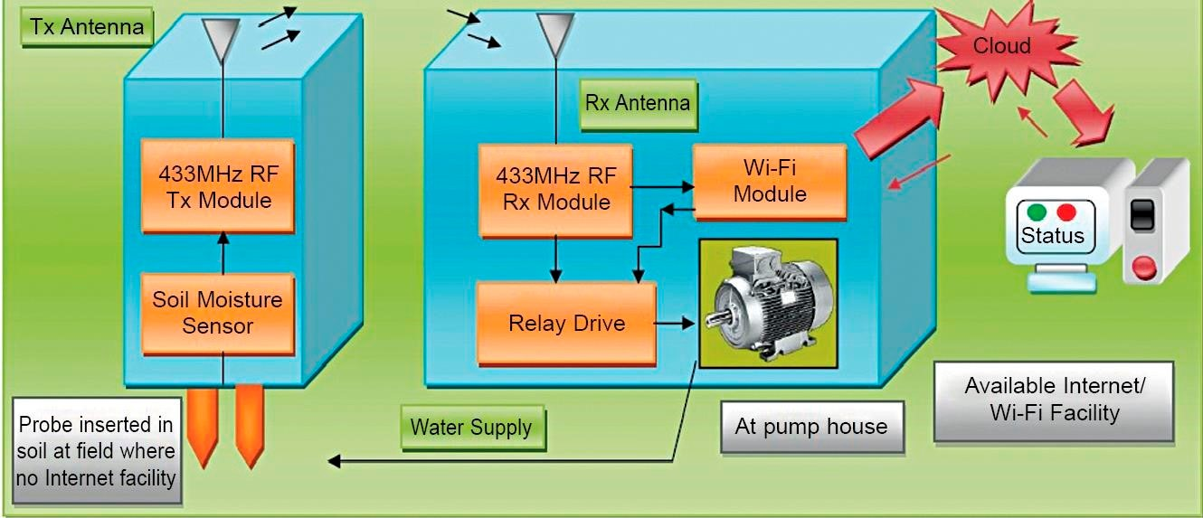

**Figure 1.** Block diagram of the proposed system.

The Android application is not only useful for remote viewing but also turns the sprinklers on and off based on the requirement of the plant(s). This system is advantageous because it can lead to reductions in labor cost and means that farmers or landowners are not required to visit the field to monitor their crops/plants. The system provides a water-saving feature, meaning that when the farmers or landowners feel that plant health could be affected due to adverse weather conditions, they will be able to sprinkle water on their plants remotely using the application. The system enables remote administration so that corrective actions can be taken before weather conditions worsen.

The IoT-based greenhouse automation system is designed in [3], where the light intensity levels and soil moisture readings are collected. The fan is automatically turned on to reduce the temperature. The system lacks the remote water sprinkling feature, and it does not provide monitoring via an Android application. The authors in [4] introduced agricultural applications based on IoT for the purposes of monitoring the moisture and nutrients of citrus, but the system is complex and costly. The authors in [5] designed an IoT-based system which allows the user to monitor their farm using mobile applications and the web. This research faced water control challenges on the farm. Systems introduced in [6,7] are useful for water control in the context of IoT-based agriculture, but are costly for farmers to use. The system introduced uses LPWAN communication and Bluetooth technologies in the farm [8]. Hence, the system will be useful only when the user is within a short distance of their farm/land.

The proposed system presented in this paper overcomes the drawbacks mentioned in the existing research and provides a cost-efficient solution for the monitoring of plants in a healthy environment.

This paper is arranged as follows: Section 2 describes the working methodology of the system. Section 3 presents the results, and Section 4 discusses the conclusions and future work.

## 2. Methodology

The IoT-based Smart Plant Monitoring System is designed to monitor and maintain the growth and health of plants. The system works by collecting data from various sensors and then sending that data to a mobile application through the internet. The system starts by collecting data from the DHT11 sensor, which measures the temperature and humidity of the environment. The data is then sent to the Arduino microcontroller, which processes the data and sends it to the Blynk app through the ESP8266 Wi-Fi module. The Blynk app then displays the temperature and humidity data in real time. If the temperature or humidity falls outside of a specified range, the Arduino sends a notification to the user’s mobile device or computer. The user can then adjust the settings on the app to optimize the environment for the plants. The solenoid valve is controlled by the Arduino based on the data from the sensors. It can be programmed to automatically open and close in order to water the plants. The relay is controlled by the Arduino, which sends a signal to the relay to open or close the valve. Overall, the system is designed to provide the user with real-time data and remote control over the environment, which can help to optimize the growth of plants and reduce the workload of the user. The Arduino microcontroller acts as the brain of the system, processing the data from the sensors and controlling the other components. The Blynk app provides a user-friendly interface for interacting with the system, and the

ESP8266 connects the system to the internet. The power adapter/power supply provides power to the system. Figure 2 depicts the testing of the proposed system on an aloe-vera plant. From this test, satisfactory results were obtained.

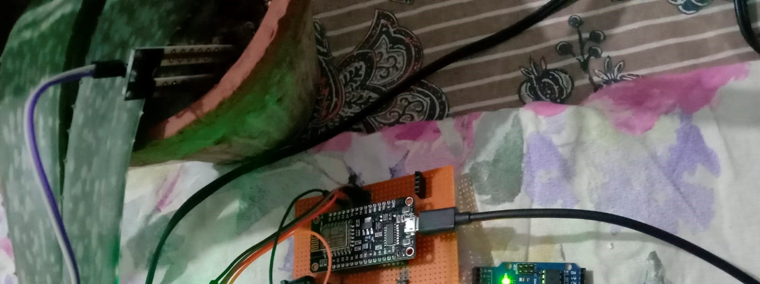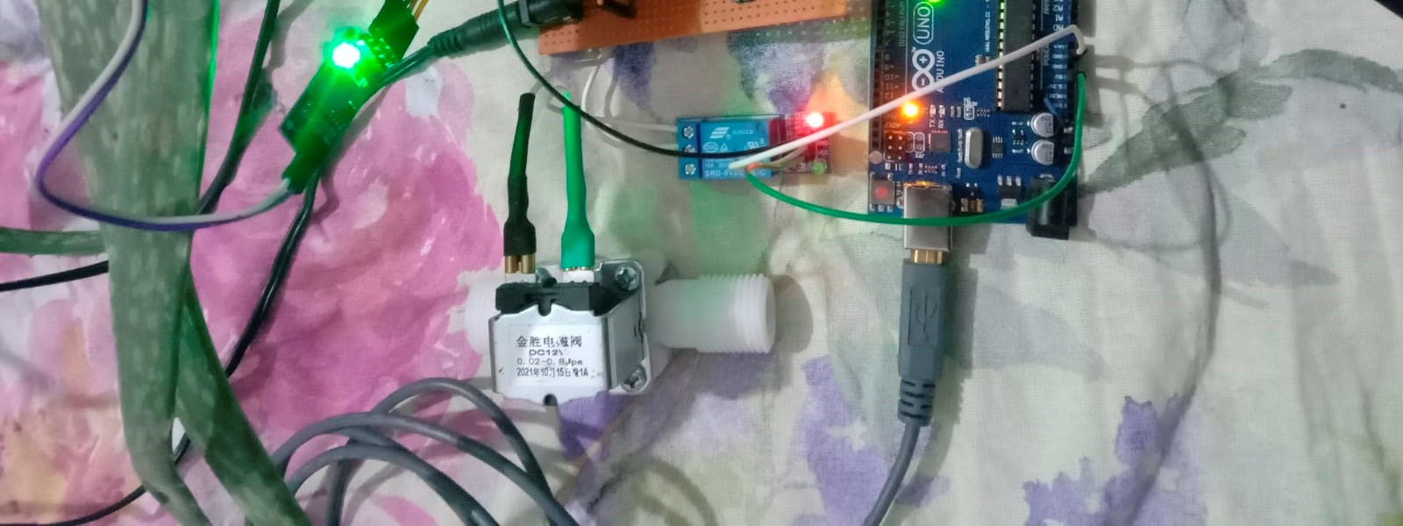

**Figure 2.** Testing of a proposed system in real-time.

## 3. Results and Analysis

Figure 3 describes the conditions when the temperature, humidity, and soil moisture levels are normal and remotely viewed by farmers on the Blynk application. Figure 4 shows that the sensor levels can be increased and remotely monitored by the farmers/owners, enabling them to further take corrective actions, such as sprinkling water via an Android application to maintain the good health of the plant. Figure 5 shows the soil water content at wilting point, field capacity and saturation points.

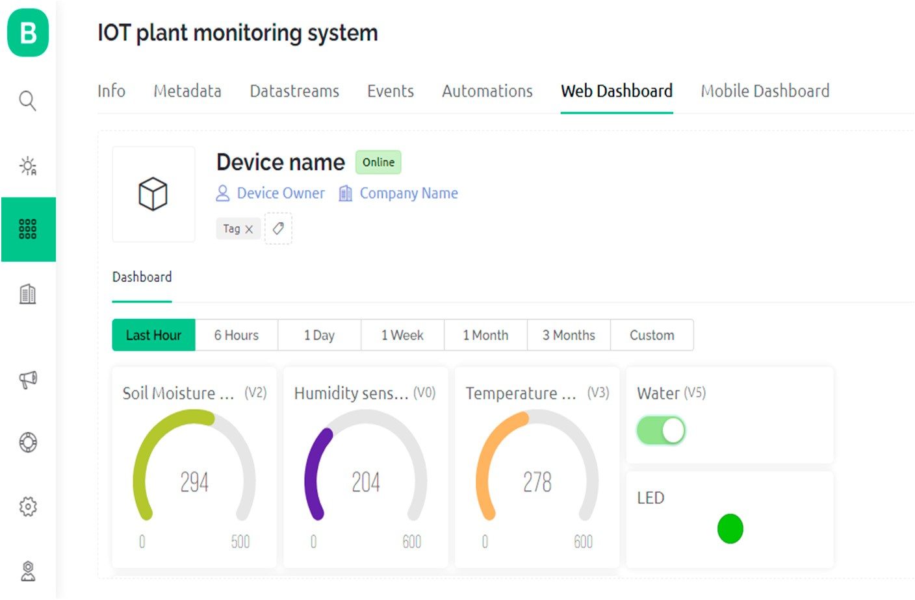

**Figure 3.** Normal conditions of Plant monitoring on Blynk app.

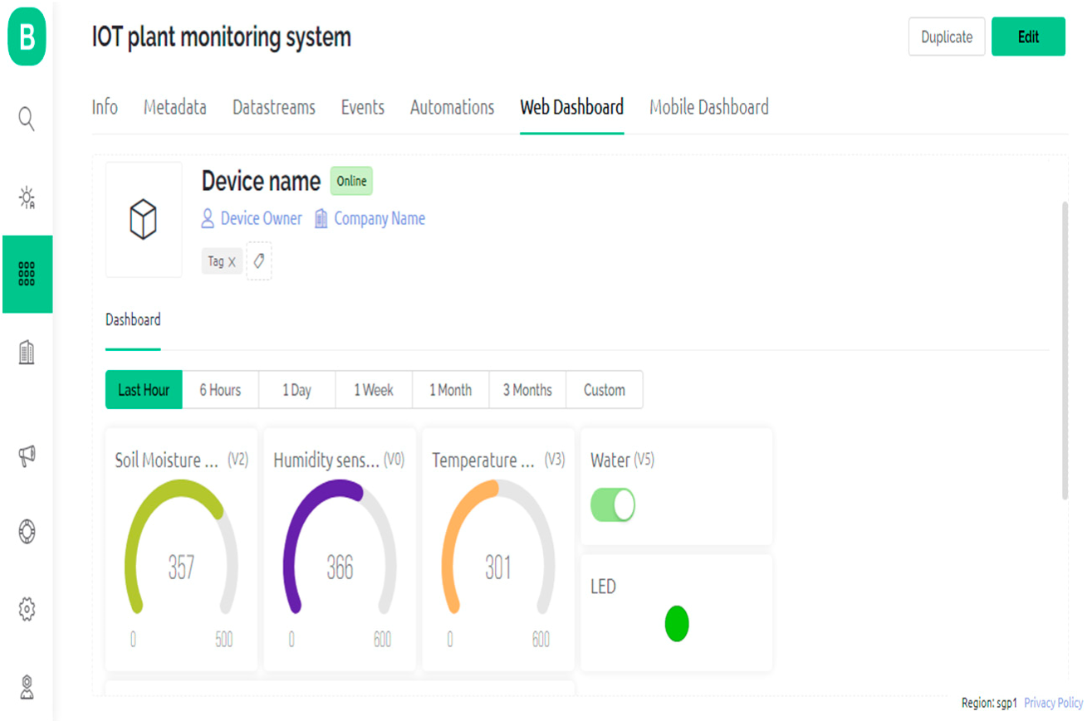

**Figure 4.** Critical conditions of Plant monitoring on Blynk app.

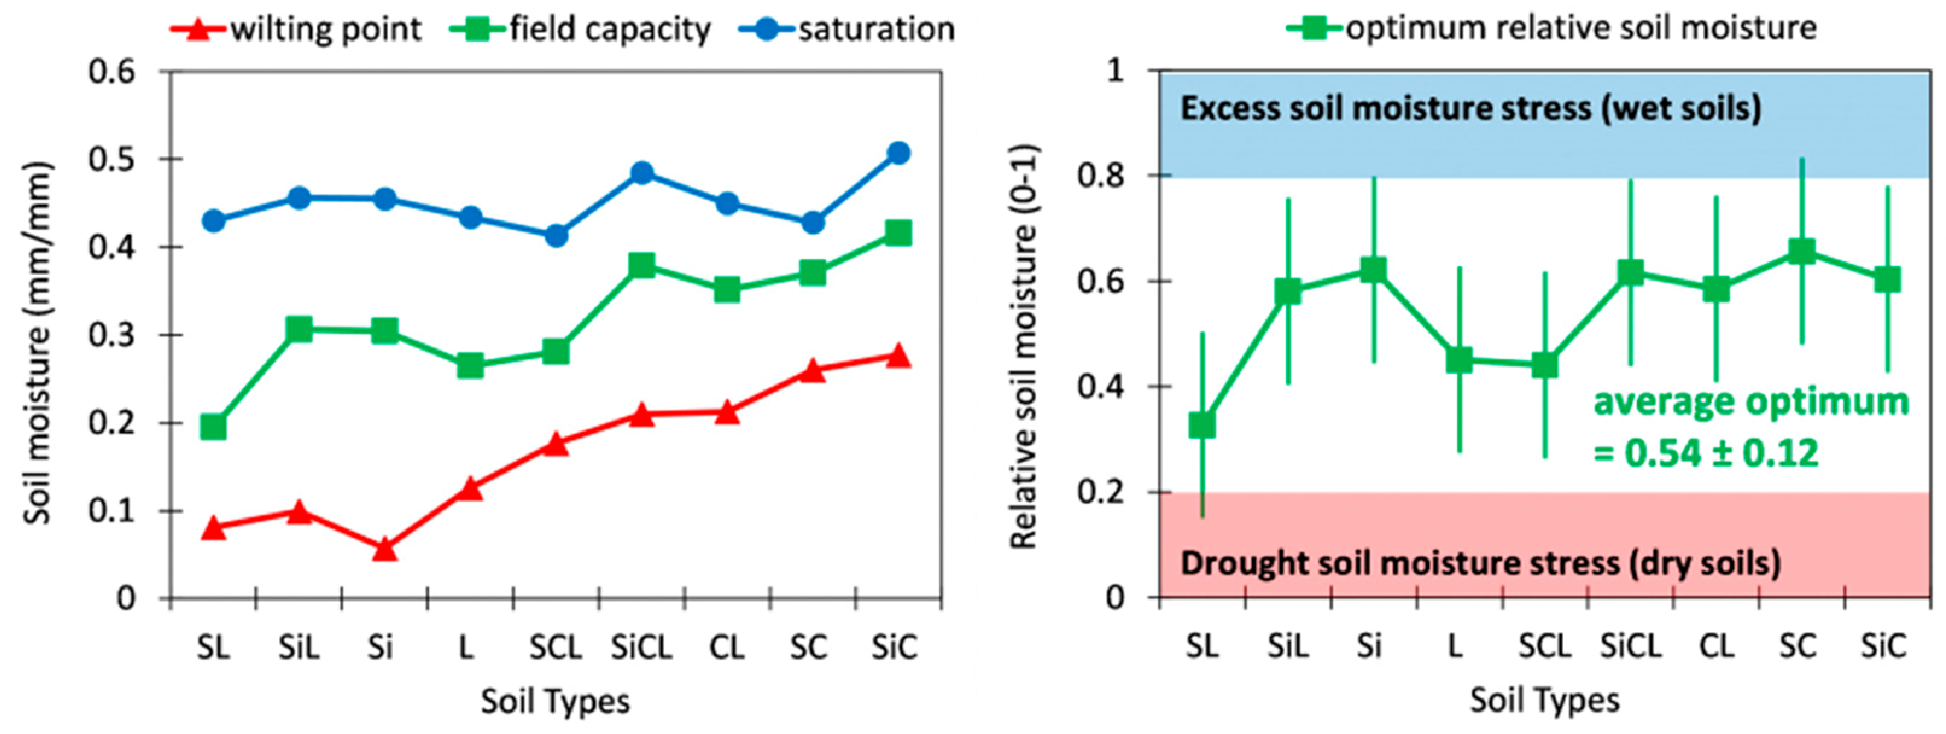

**Figure 5.** Soil moisture vs. Soil types.

## 4. Conclusion and Future Work

The IoT-based Smart Plant Monitoring System is a powerful and versatile system that allows users to monitor and control various aspects of their plants remotely. It is a highly customizable and cost-effective solution for monitoring and controlling plants remotely. The system can be easily integrated with other devices and platforms and can be used for a wide range of applications, such as greenhouse monitoring, crop monitoring, and irrigation control. With the help of this system, the user can keep track of the temperature, humidity, soil moisture, and other important parameters of their plants and take appropriate actions to ensure the optimal growth and health of their plants. The system can be extended further by adding more sensors or actuators to monitor and control other aspects of the plants.

**Author Contributions:** Conceptualization, methodology, visualization, data curation, M.H.A.; software, investigation, W.Z.; validation, G.F.M.; resources, formal analysis, Y.J. and N.M.; writing— original draft preparation, writing—review, and editing, supervision, project administration, G.F.M. All authors have read and agreed to the published version of the manuscript.

**Funding:** This research received no external funding.

**Institutional Review Board Statement:** Not applicable.

**Informed Consent Statement:** Not applicable.

**Data Availability Statement:** Not applicable.

**Conflicts of Interest:** The authors declare no conflict of interest.

## References

1. Hati, A.J.; Singh, R.R. Smart Indoor Farms: Leveraging Technological Advancements to Power a Sustainable Agricultural Revolution. *AgriEngineering* **2021**, *3*, 728–767. [[CrossRef]](https://doi.org/10.3390/agriengineering3040047)
2. Chen, C.-H.; Jeng, S.-Y.; Lin, C.-J. Fuzzy Logic Controller for Automating Electrical Conductivity and pH in Hydroponic Cultivation. *Appl. Sci.* **2022**, *12*, 405. [[CrossRef]](https://doi.org/10.3390/app12010405)
3. Shirsath, D.O.; Kamble, P.; Mane, R.; Kolap, A.; More, R.S. IOT Based Smart Greenhouse Automation Using Arduino. *Int. J. Innov. Res. Comput. Sci. Technol.* **2017**, *5*, 234–238. [[CrossRef]](https://doi.org/10.21276/ijircst.2017.5.2.4)
4. Zhang, X.; Zhang, J.; Li, L.; Zhang, Y.; Yang, G. Monitoring Citrus Soil Moisture and Nutrients Using an IoT Based System. *Sensors* **2017**, *17*, 447. [[CrossRef]](https://doi.org/10.3390/s17030447) [[PubMed]](https://www.ncbi.nlm.nih.gov/pubmed/28241488)
5. Muangprathuba, J.; Boonnama, B.; Kajornkasirat, S.; Lekbangpong, N.; Wanichsombat, A.; Nillaor, P. IoT and agriculture data analysis for the smart farm. *Comput. Electron. Agric.* **2019**, *156*, 467–474. [[CrossRef]](https://doi.org/10.1016/j.compag.2018.12.011)
6. Nobrega, L.; Golcalves, P.; Pedreiras, P.; Pereira, J. An IoT-Based Solution for Intelligent Farming. *Sensors* **2019**, *19*, 603. [[CrossRef]](https://doi.org/10.3390/s19030603) [[PubMed]](https://www.ncbi.nlm.nih.gov/pubmed/30709013)
7. Touseau, L.; Le Sommer, N. Contribution of the Web of Things and the Opportunistic Computing to the Smart Agriculture: A Practical Experiment. *Sensors* **2019**, *11*, 33. [[CrossRef]](https://doi.org/10.3390/fi11020033)
8. Chiyurl, Y.; Miyoung, H.; Changkyu, L. SWAMP: Implement Smart Farm with IoT Technology. In Proceedings of the International Conference on Advanced Communications Technology (ICACT), Chuncheon-si, Gangwon-do, Republic of Korea, 11–14 February 2018.

**Disclaimer/Publisher’s Note:** The statements, opinions and data contained in all publications are solely those of the individual author(s) and contributor(s) and not of MDPI and/or the editor(s). MDPI and/or the editor(s) disclaim responsibility for any injury to people or property resulting from any ideas, methods, instructions or products referred to in the content.